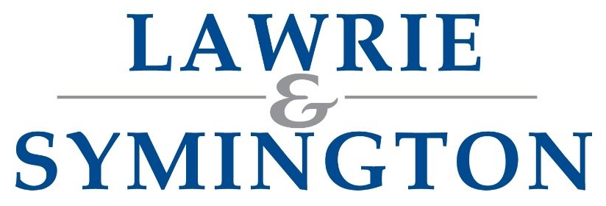

Our Ref: AH/JWB

24th July 2024

Dear Member,

Please find enclosed entry forms ahead of this year’s show & sale. Details are timetabled below:

Sale: | Society Show and Sale of Border Leicester Sheep  (on behalf of the Society of Border Leicester Sheep Breeders)
Show & Sale Date: | Wednesday 18th September 2024 (Show 9.30am / Sale: 12noon – tbc)
Judge: | per Society tbc
Sponsor: | Classes: per Society tbc
Inspection/Arrival: | Arrival: accepted evening before from approx. 6pm  Inspection: N/A
Status of Sale: | MV Accredited, Non-Eligible for Export
Closing Date: | Tuesday 13th August at strictly 12noon (NO LATE ENTRIES WILL BE ACCEPTED)  Link to entry form: https://lawrieandsymington.com/entry-forms/
Entry Fee: | £12ph (£10+VAT) (Payable to Lawrie & Symington Ltd and MUST be paid with submission of Entries, otherwise entries will be withdrawn from Catalogue)  BACS Details – Sort Code 80-17-02 / Account – 00110611 (Ref Surname, Border Leicester)
Substitutes: | Monday 16th September at strictly 12noon to Lanark Office (List available online/sale day)
Society Membership: | Must be fully paid member of the Society of Border Leicester Sheep Breeders

Society of Border Leicester Sheep Breeders – Entry Rules: All sheep entered must be Birth Notified before submission of entries. This is your responsibility as the vendor/breeder, failure to do so will incur immediate rejection of entry.

Entries to be returned to the Lanark office or can be emailed to jenna@lawrieandsymington.com or Whatsapp to Jenna.

We thank you in anticipation of your entries, and if we can be of further assistance, then please do not hesitate to contact myself on 07917 624409, Nick Woodmass on 07778 449383, or Jenna Ballantyne on 07799 845923.

Yours faithfully
For LAWRIE & SYMINGTON LIMITED
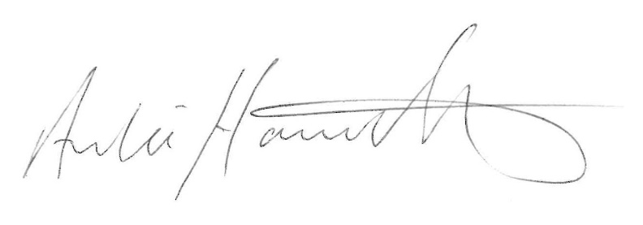
Archie Hamilton A.I.A. (Scot)
Head of Sheep Sales

Enc.
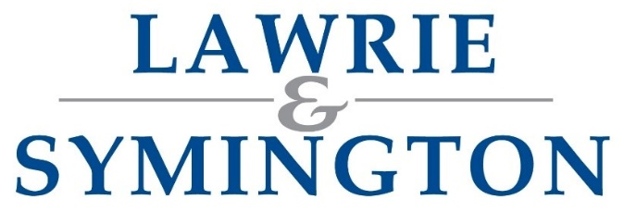 | BORDER LEICESTER  SHOW & SALE  ENTRY FORM | 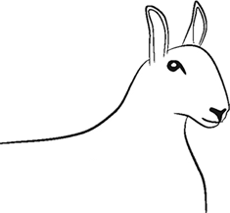

SHOW & SALE: WEDNESDAY 18TH SEPTEMBER 2024

Vendor’s Trading Name: |  |  | Flock Prefix:
Address:
(inc. Postcode)
Contact Number:
Email:
Sort Code: |  | Account Number:
Holding Number (CPH): |  | Herd/Flock Number:
VAT receipt required for Entry Fees? |  | YES |  | NO

FEMALE (ALL CLASSES) – ENTRY FORM

Embryos
Flock Code Letter Individual Ear Tag Age Classification (Ewe, Gimmer, Ewe Lamb) Collected (Yes/No)
1.

NOTES:

Embryos
Flock Code Letter Individual Ear Tag Age Classification (Ewe, Gimmer, Ewe Lamb) Collected (Yes/No)
2.

NOTES:

Embryos
Flock Code Letter Individual Ear Tag Age Classification (Ewe, Gimmer, Ewe Lamb) Collected (Yes/No)
3.

NOTES:

Embryos
Flock Code Letter Individual Ear Tag Age Classification (Ewe, Gimmer, Ewe Lamb) Collected (Yes/No)
4.

NOTES:

Continued Overleaf /

FEMALE (ALL CLASSES) – ENTRY FORM (Continued)

Embryos
Flock Code Letter Individual Ear Tag Age Classification (Ewe, Gimmer, Ewe Lamb) Collected (Yes/No)
5.

NOTES:

Embryos
Flock Code Letter Individual Ear Tag Age Classification (Ewe, Gimmer, Ewe Lamb) Collected (Yes/No)
6.

NOTES:

Embryos
Flock Code Letter Individual Ear Tag Age Classification (Ewe, Gimmer, Ewe Lamb) Collected (Yes/No)
7.

NOTES:

Embryos
Flock Code Letter Individual Ear Tag Age Classification (Ewe, Gimmer, Ewe Lamb) Collected (Yes/No)
8.

NOTES:

Embryos
Flock Code Letter Individual Ear Tag Age Classification (Ewe, Gimmer, Ewe Lamb) Collected (Yes/No)
9.

NOTES:

Embryos
Flock Code Letter Individual Ear Tag Age Classification (Ewe, Gimmer/Shearling Ewe, Ewe Lamb) Collected (Yes/No)
10.

NOTES:

(Further entries can be attached on separate sheet)

Final Entries close at strictly 12noon – per date highlighted in letter

Options to return Completed Forms (choose 1 option only):
Email: jenna@lawrieandsymington.com
Whatsapp: 07799845923
Postal: Lawrie & Symington Ltd, Lanark Agricultural Centre, Lanark, ML11 9AX

Entry Fee: as highlighted within letter (due at time of entry) Commission Rate: 5%

BORDER LEICESTER
SHOW & SALE

ENTRY FORM

SHOW & SALE: WEDNESDAY 18TH SEPTEMBER 2024

Vendor’s Trading Name: |  |  | Flock Prefix:
Address:
(inc. Postcode)
Contact Number:
Email:
Sort Code: |  | Account Number:
Holding Number (CPH): |  | Herd/Flock Number:
VAT receipt required for Entry Fees? |  | YES |  | NO

MALE (ALL CLASSES) – ENTRY FORM

Semen
Flock Code Letter Individual Ear Tag Age Classification (Ram, Shearling Ram, Ram Lamb) Collected (Yes/No)
1.

NOTES:

Semen
Flock Code Letter Individual Ear Tag Age Classification (Ram, Shearling Ram, Ram Lamb) Collected (Yes/No)
2.

NOTES:

Semen
Flock Code Letter Individual Ear Tag Age Classification (Ram, Shearling Ram, Ram Lamb) Collected (Yes/No)
3.

NOTES:

Semen
Flock Code Letter Individual Ear Tag Age Classification (Ram, Shearling Ram, Ram Lamb) Collected (Yes/No)
4.

NOTES:

Continued Overleaf /

MALE (ALL CLASSES) – ENTRY FORM (Continued)

Semen
Flock Code Letter Individual Ear Tag Age Classification (Ram, Shearling Ram, Ram Lamb) Collected (Yes/No)
5.

NOTES:

Semen
Flock Code Letter Individual Ear Tag Age Classification (Ram, Shearling Ram, Ram Lamb) Collected (Yes/No)
6.

NOTES:

Semen
Flock Code Letter Individual Ear Tag Age Classification (Ram, Shearling Ram, Ram Lamb) Collected (Yes/No)
7.

NOTES:

Semen
Flock Code Letter Individual Ear Tag Age Classification (Ram, Shearling Ram, Ram Lamb) Collected (Yes/No)
8.

NOTES:

Semen
Flock Code Letter Individual Ear Tag Age Classification (Ram, Shearling Ram, Ram Lamb) Collected (Yes/No)
9.

NOTES:

Semen
Flock Code Letter Individual Ear Tag Age Classification (Ram, Shearling Ram, Ram Lamb) Collected (Yes/No)
10.

NOTES:

(Further entries can be attached on separate sheet)

Final Entries close at strictly 12noon – per date highlighted in letter

Options to return Completed Forms (choose 1 option only):
Email: jenna@lawrieandsymington.com
Whatsapp: 07799845923
Postal: Lawrie & Symington Ltd, Lanark Agricultural Centre, Lanark, ML11 9AX

Entry Fee: as highlighted within letter (due at time of entry) Commission Rate: 5%

